

**Birsha Institute of Technology Sindri, Dhanbad**

Java Assignment

Prof. – Tapan Kumar Nayak

Name – Dhananjay Ghosh

Branch – Information Technology

Roll No. – 2011013

Reg. No. – 20030480010

1. Get a number of keyboards using util package and display the number at unit place.

Program :-

import java.util.Scanner;

public class program1 {

public static void main(String[] args) {

//Create new scanner

Scanner input = new Scanner(System.in);

int ones = 0;

System.out.print("Enter a number: ");

int number = input.nextInt();

//Display ones digit

ones = (number%10);

System.out.printf("Ones place digit: " + ones);

}

}

Output :-

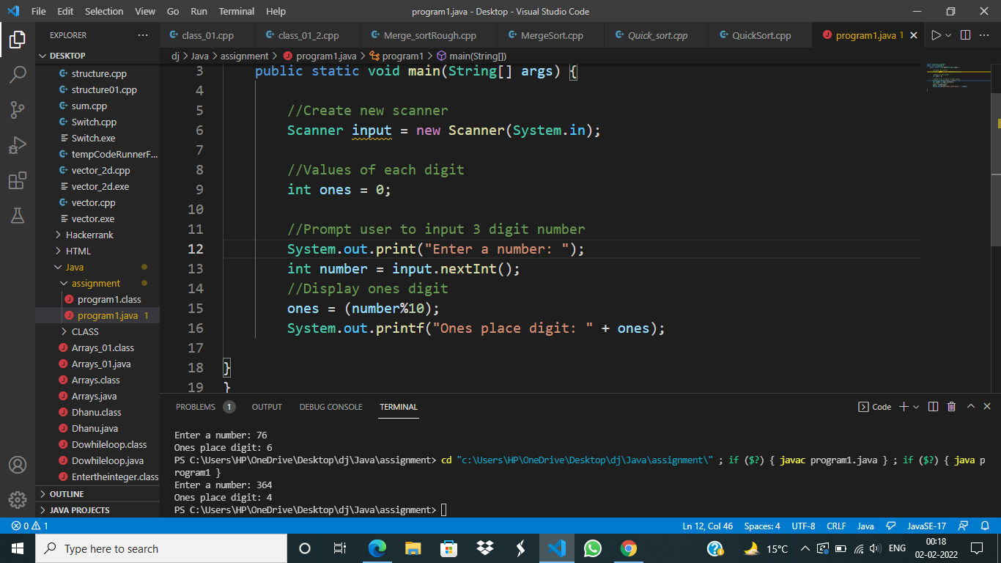

1. Get a number from the keyboard and display the Fibonacci series.

Program :-

import java.util.Scanner;

public class program2 {

public static int fibo(int pos){

if (pos == 1) {

return 0;

}

if (pos == 2) {

return 1;

}

return fibo(pos-1)+fibo(pos-2);

}

public static void main(String[] args) {

Scanner sc = new Scanner(System.in);

int pos = sc.nextInt();

System.out.println("Dhananjay Ghosh");

for (int i = 1; i <= pos; i++) {

System.out.print(fibo(i)+" ");

}

}

}

Output :-

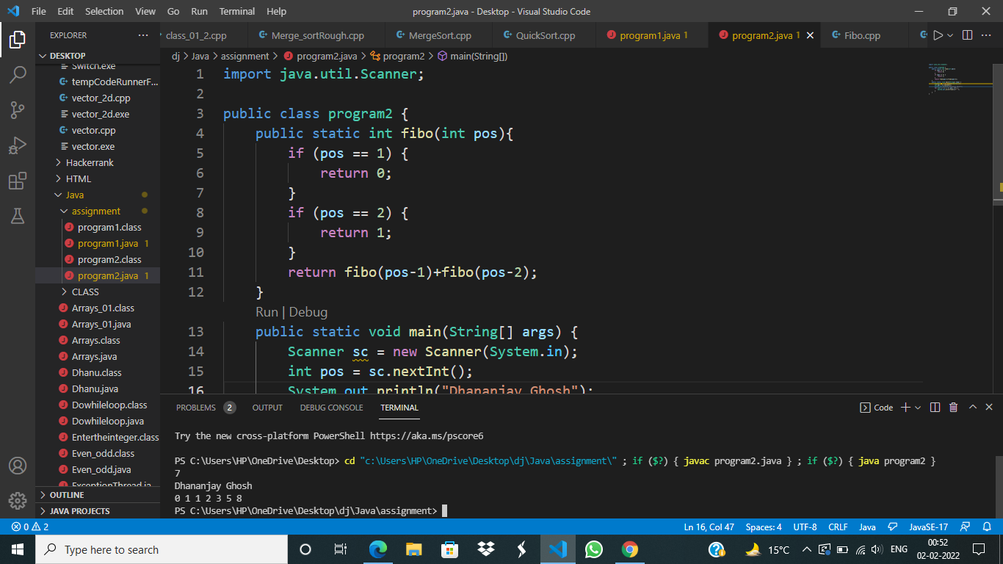

1. Get three numbers from the keyboard and print their sum.

Program :-

import java.util.Scanner;

public class program3 {

public static void main(String[] args) {

Scanner sc = new Scanner(System.in);

int num1 = sc.nextInt();

int num2 = sc.nextInt();

int num3 = sc.nextInt();

System.out.println("Dhananjay Ghosh");

System.out.println(num1+num2+num3);

}

}

Output :-

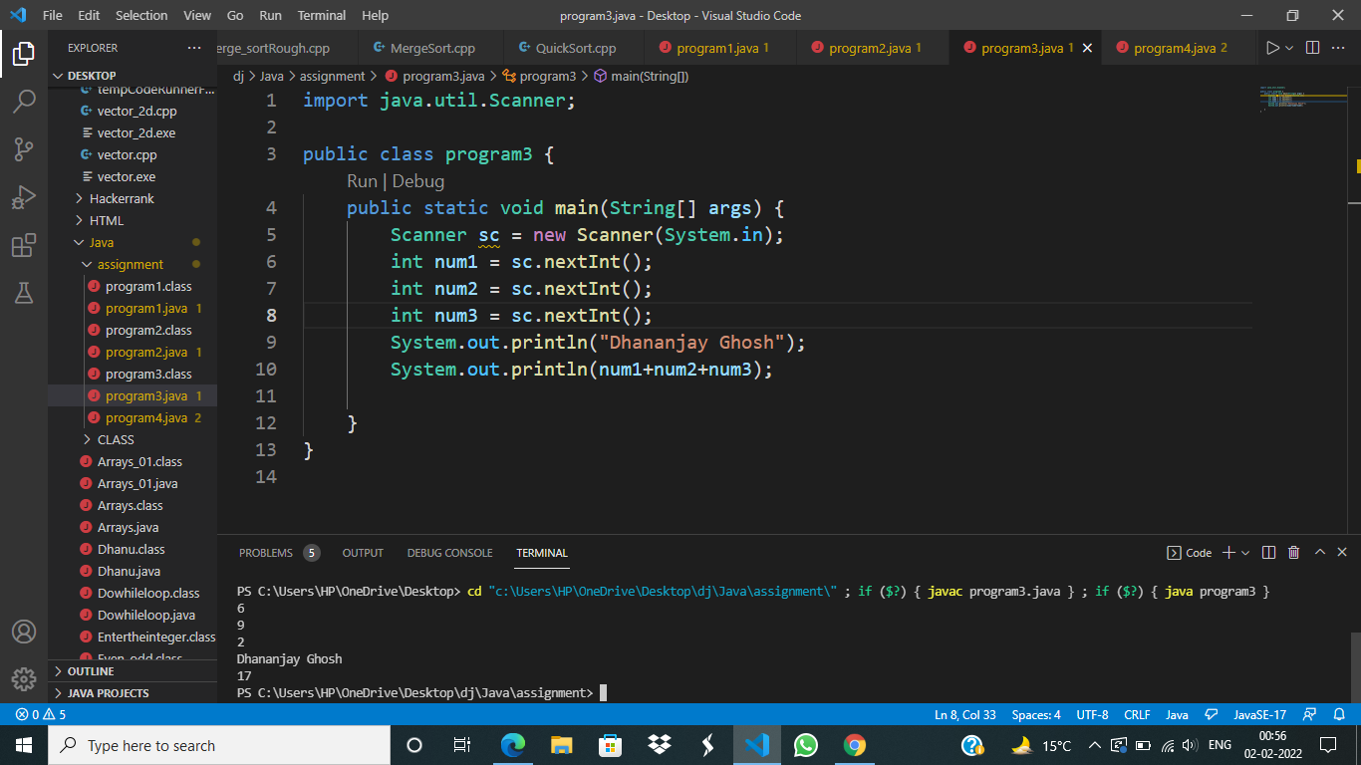

1. WAP to enter a string from the keyboard and print the number of vowels in the string.

Program :-

import java.util.Scanner;

public class program4 {

public static void main(String[] args) {

Scanner sc = new Scanner(System.in);

String str = sc.nextLine();

System.out.println("Dhananjay Ghosh");

int k = 0;

for (int i = 0; i < str.length(); i++) {

if (str.charAt(i) == 'a'|| str.charAt(i) == 'A' || str.charAt(i) == 'e'||str.charAt(i) == 'E'|| str.charAt(i) == 'i' || str.charAt(i) == 'I'||str.charAt(i) == 'o'|| str.charAt(i) == 'O' || str.charAt(i) == 'u'||str.charAt(i) == 'U') {

k++;

}

}

System.out.println(k);

}

}

Output :-

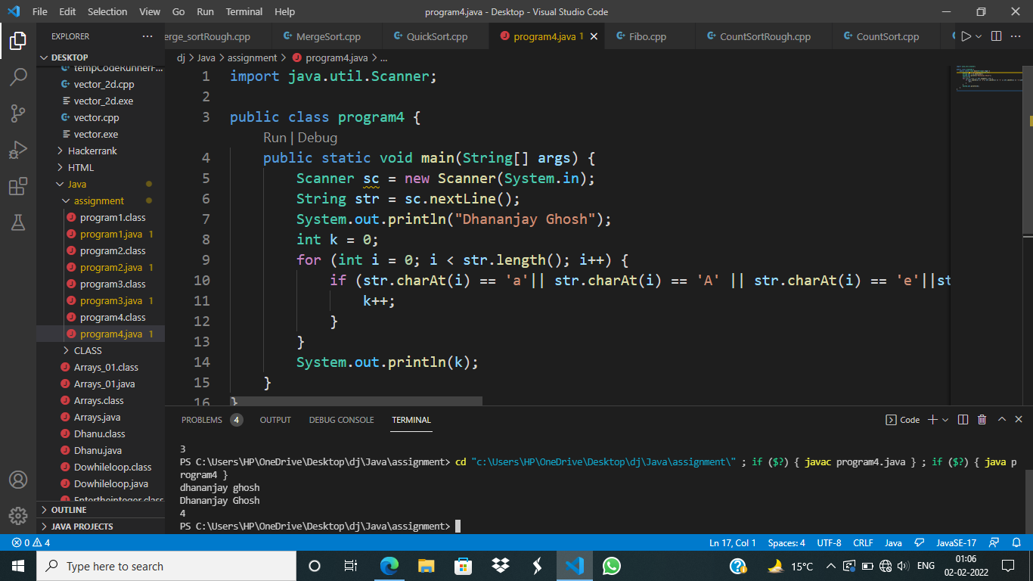

1. WAP to enter a number from the keyboard and check that the number is Armstrong number or not.

Program :-

import java.util.Scanner;

public class program5 {

public static int pow(int num, int pwr) {

if (pwr == 1) {

return num;

}

return num * pow(num, (pwr - 1));

}

public static boolean armstrong(int num) {

int sum = 0;

int temp = num;

int temp1 = num;

int digit = 0;

while (temp1 != 0) {

digit++;

temp1 = temp1 / 10;

}

while (temp != 0) {

sum = sum + pow((temp % 10), digit);

temp = temp / 10;

}

return (sum == num);

}

public static void main(String[] args) {

Scanner sc = new Scanner(System.in);

int number = sc.nextInt();

System.out.println(armstrong(number));

}

}

Output:-

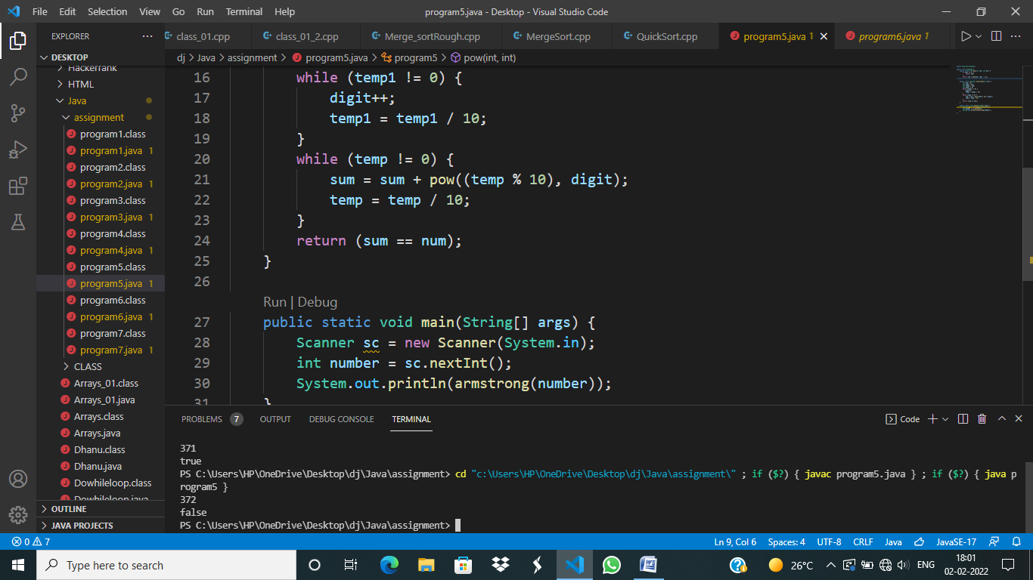

1. WAP to enter a number from keyboard and display star pattern with same width and same height (i.e., rectangle and square).

Program :-

import java.util.Scanner;

public class program6 {

public static void main(String[] args) {

Scanner sc = new Scanner(System.in);

int num = sc.nextInt();

System.out.println("Dhananjay Ghosh");

for (int i = 0; i < num; i++) {

for (int j = 0; j < num; j++) {

System.out.print(" * ");

}

System.out.println();

}

}

}

Output :-

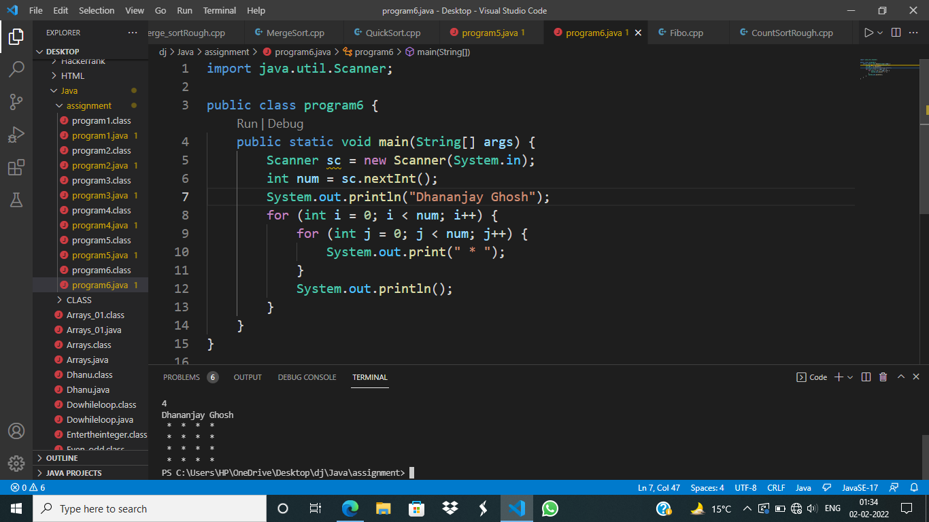

1. WAP to enter a number from keyboard and display star pattern with same width and same height.

Program :-

import java.util.Scanner;

public class program7 {

public static void main(String[] args) {

Scanner sc = new Scanner(System.in);

int height = sc.nextInt();

height = height*2;

for (int i = 0; i < height/2; i++) {

for (int j = 0; j < height; j++) {

if (j == (height/2-i)) {

for (int k = 0; k < 2*i+1; k++) {

System.out.print("*");

}

break;

}

else {

System.out.print(" ");

}

}

System.out.println();

}

}

}

Output :-

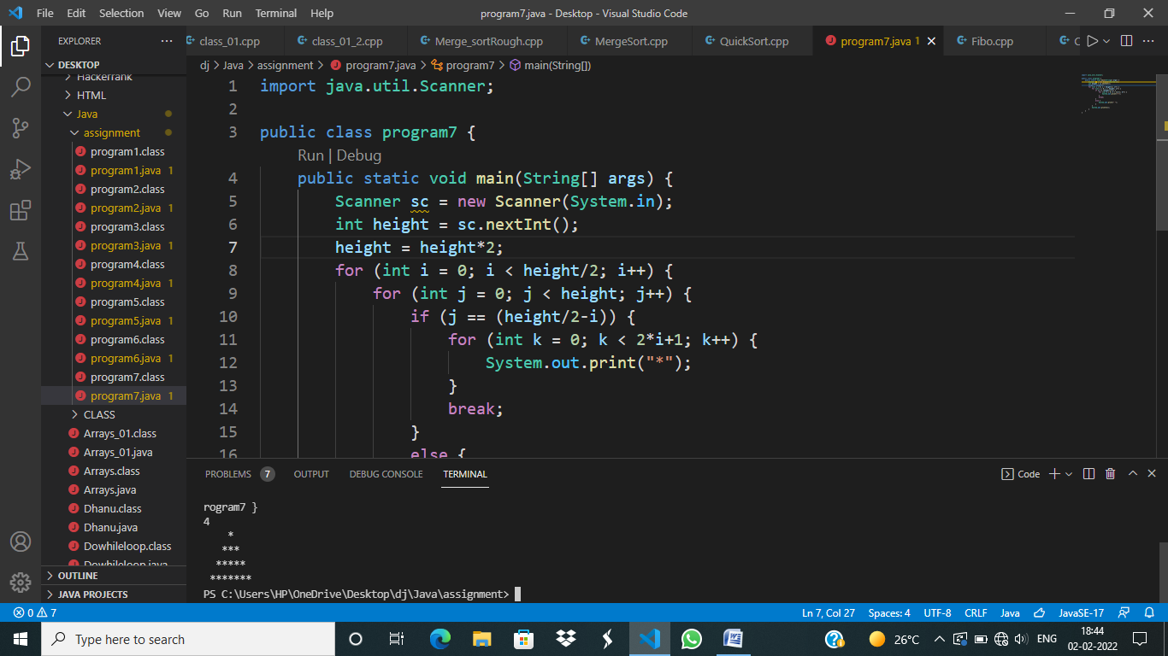

1. WAP to enter a string from keyboard and display the same string by changing the cases of the string (i.e., lower to upper & upper to lower).

Program :-

Output :-

1. WAP to enter string from keyboard and display the addition result of ASCII values of respective character.

Program :-

Output :-

1. WAP to enter a character and display its ASCII value and if “ASCII value > 70” then print next character.

Program :-

Output :-

1. Write a java program to print even and odd using bufferreader class.

Program :-

Output :-

1. Write a program to call constructor, parameterized constructor and copy constructor respectively.

Program :-

Output :-

1. Write a program showing use of ‘this’ keyword.

Program :-

public class program13 {

int a;

public program13(int a) {

this.a = a;

}

public static void main(String[] args) {

System.out.println("Dhananjay Ghosh");

program13 thisKey = new program13(5);

System.out.println("The key is : " + thisKey.a);

}

}

Output :-

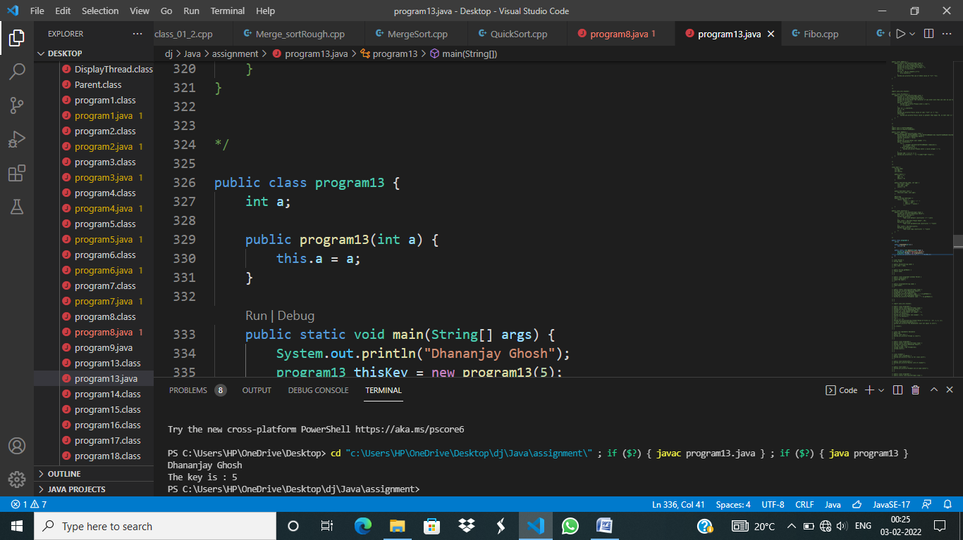

1. Write a java program for single inheritance about constructor.

Program :-

class Parent {

String name;

public Parent(String name) {

this.name = name;

}

public String getName() {

return name;

}

}

public class program14 extends Parent {

public program14() {

super("No name");

}

public program14(String name) {

super(name);

}

public static void main(String[] args) {

System.out.println("Dhananjay Ghosh");

program14 s1 = new program14();

System.out.println("Default name : " + s1.getName());

program14 s2 = new program14("Rahul");

System.out.println("Parameter name : " + s2.getName());

}

}

Output :-

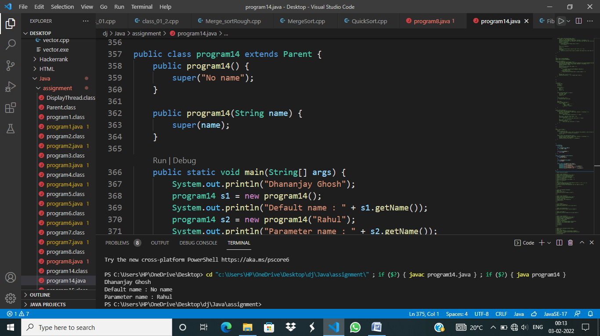

1. Write a java program for exception handling.

Program :-

import java.util.Scanner;

public class program15 {

public static void main(String[] args) {

System.out.println("Dhananjay Ghosh");

Scanner sc = new Scanner(System.in);

System.out.print("Enter 1st number : ");

int a = sc.nextInt();

System.out.print("Enter 2nd element : ");

int b = sc.nextInt();

try {

int c = a / b;

System.out.println(String.format("Value of %s/%s is : %s", a, b, c));

} catch (ArithmeticException e) {

System.out.println("The denominator must not equal to zero");

}

sc.close();

}

}

Output :-

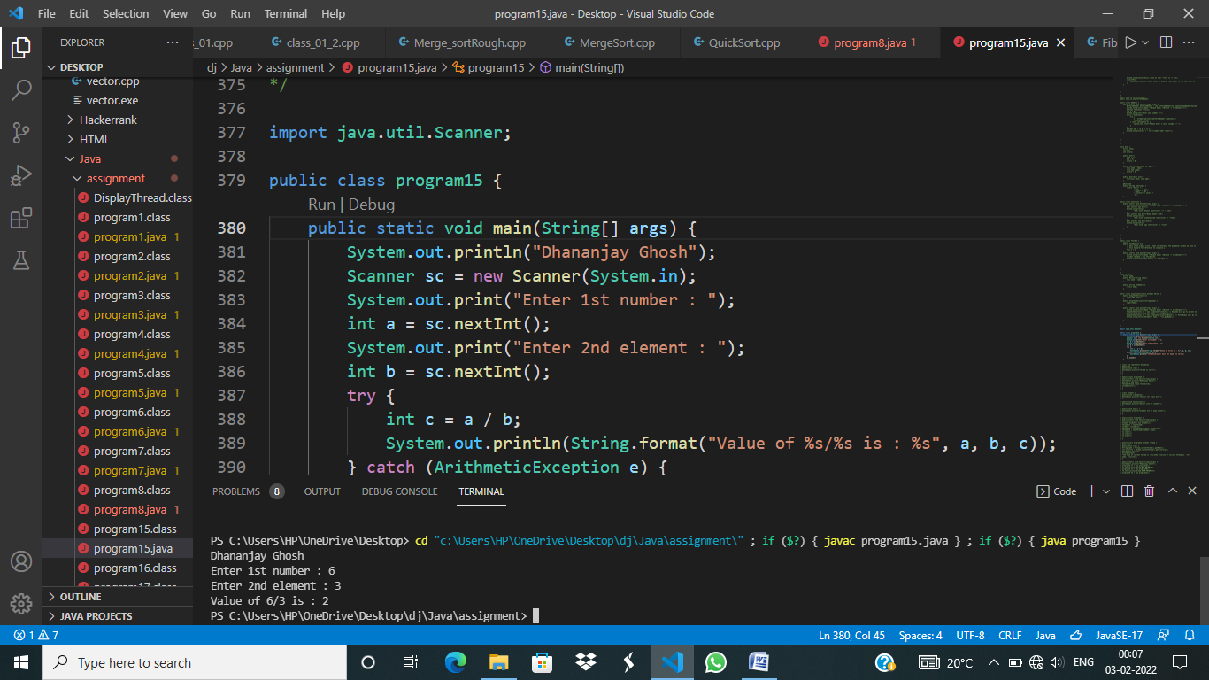

1. Program to implement thread using runnable interface.

Program :-

class Trd implements Runnable{

@Override

public void run() {

System.out.println("Thread is start");

}

}

public class program16 {

public static void main(String[] args) {

System.out.println("Dhananjay Ghosh");

Trd trd = new Trd();

Thread thread = new Thread(trd);

thread.start();

}

}

Output :-

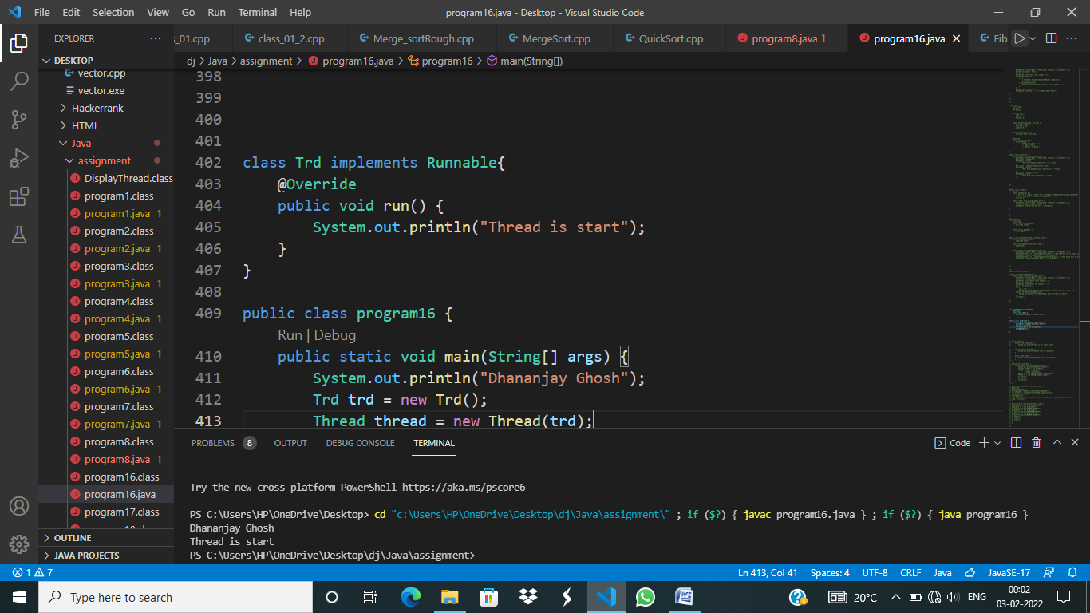

1. Program to creating multiple thread for a student activity in college i.e., thread for class work, thread for hostel life, thread for exams.

Program :-

class Student {

public void classWork() {

System.out.println("This is for class work");

}

public void hostelLife() {

System.out.println("Hostel life of student");

}

public void exam() {

System.out.println("Student are at exam center");

}

}

public class program17 {

public static void main(String[] args) {

System.out.println("Dhananjay Ghosh");

Student student = new Student();

Thread t1 = new Thread(

student::classWork);

Thread t2 = new Thread(student::hostelLife);

Thread t3 = new Thread(student::exam);

t1.start();

t2.start();

t3.start();

}

}

Output :-

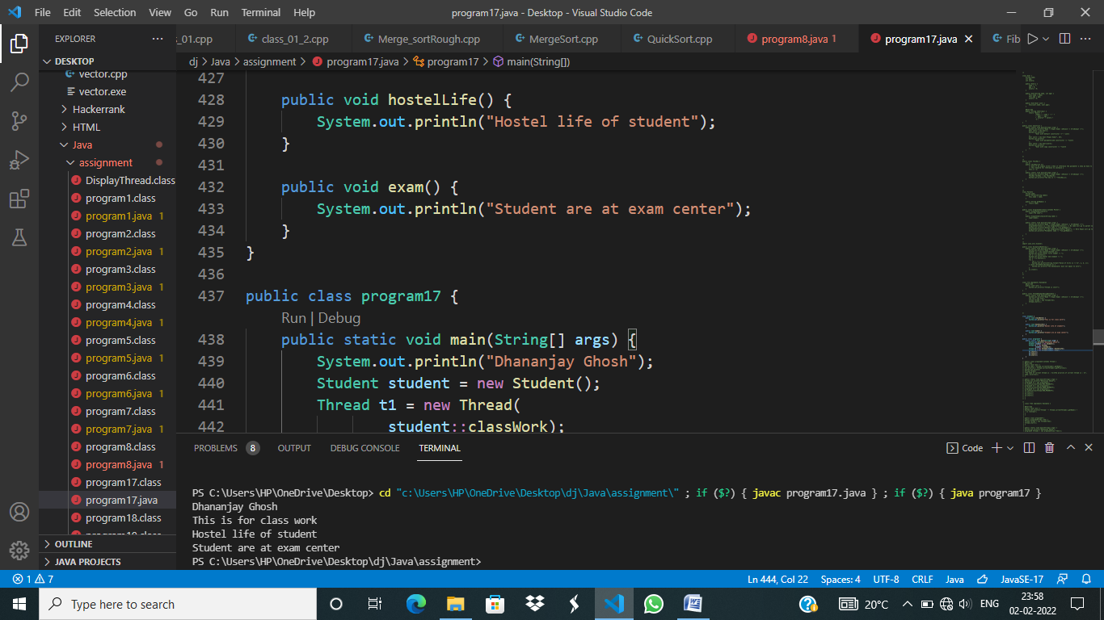

1. Program to set priorities of thread by creating three thread with different bodies.

Program :-

public class program18 extends Thread {

@Override

public void run() {

String name = Thread.currentThread().getName();

int priority = Thread.currentThread().getPriority();

System.out.println(

String.format(

"The name of current thread is : %s\nThe priority of current thread is : %s", name, priority));

}

public static void main(String[] args) {

System.out.println("Dhananjay Ghosh");

program18 t1 = new program18();

t1.setPriority(Thread.MAX_PRIORITY);

program18 t2 = new program18();

t2.setPriority(Thread.NORM_PRIORITY);

program18 t3 = new program18();

t3.setPriority(Thread.MIN_PRIORITY);

t1.start();

t2.start();

t3.start();

}

}

Output :-

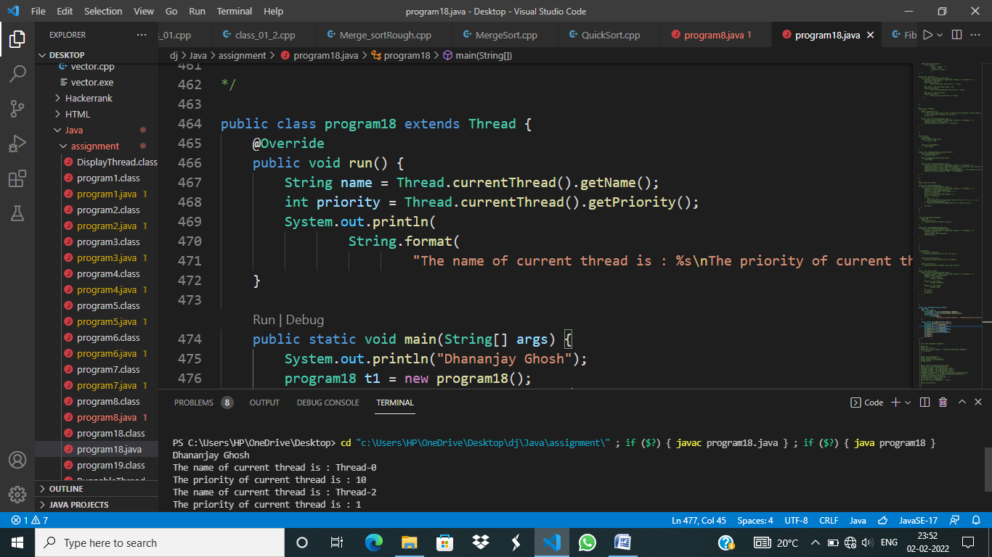

1. Program to display all running thread.

Program :-

class Trd2 implements Runnable {

@Override

public void run() {

System.out.println("Thread " + Thread.currentThread().getName() + " is running");

}

}

public class program19 {

public program19(Trd2 trd2) {

Thread thread = new Thread(trd2);

thread.start();

}

public static void main(String[] args) {

System.out.println("Dhananjay Ghosh");

program19 thread1 = new program19(new Trd2());

program19 thread2 = new program19(new Trd2());

program19 thread3 = new program19(new Trd2());

ThreadGroup threadGroup = Thread.currentThread().getThreadGroup();

Thread[] threadList = new Thread[threadGroup.activeCount()];

threadGroup.enumerate(threadList);

System.out.print("Active Thread are : ");

for (Thread trd : threadList) {

System.out.print(trd.getName() + "\n\t");

}

System.out.println();

}

}

Output :-

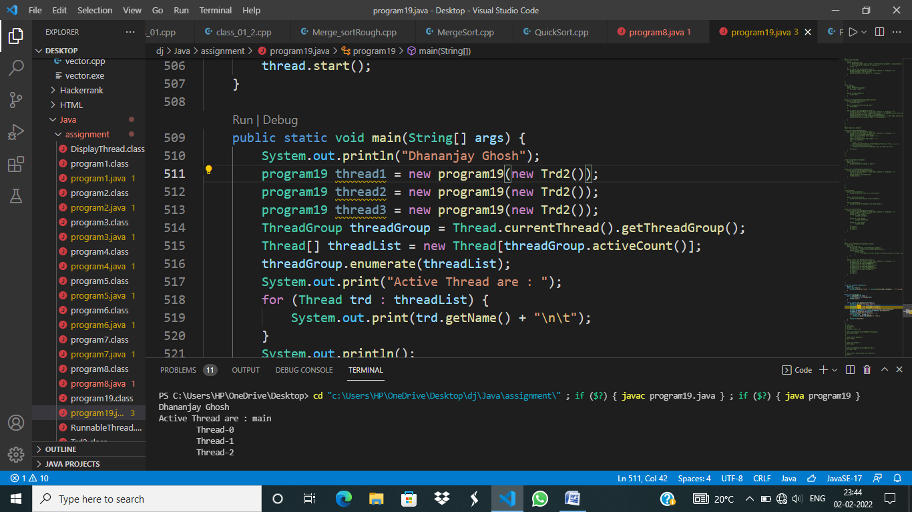

1. Program for Synchronization with object level lock and class level lock.

Program :-

Output :-

1. Program to print Fibonacci & reverse series.

Program :-

Output :-